Using Marking Guides to Grade Assignments 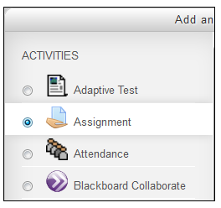

A marking guide is a grading method where a teacher enters a comment and grades per criterion.

Contents
- Create a Marking Guide
New Assignment
Pre-existing Assignment
- Marking Assignments
- Use a previously created Marking Guide for another Assignment in a Moodle course
- To Edit or Delete a Marking Guide

Create a Marking Guide for a new Assignment

When creating a new assignment, refer to the directions on how to Add a new assignment and under Grading method select Marking guide.
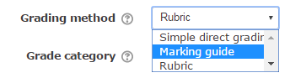

When you have completed the settings for your new assignment, click Save and display. The Advanced grading page will appear. You will be prompted to select whether you wish to Define new grading form from scratch or Create a new grading form from a template.
Follow directions below on how to add a Marking Guide Method 2 to a pre-existing assignment starting at #7.

Create a Marking Guide for a pre-existing Assignment
There are two methods to change your marking method in an assignment to a Marking Guide.

Method One:
- Go to the course home page.
- Turn editing on.
- Click on the Edit settings for the Assignment activity. Change the Grading method to Marking Guide.


4. Click on Save and display and the Advanced grading page will appear. You will be prompted to select whether you wish to Define new grading form from scratch or Create a new grading form from a template.
5. Select Define new grading form from scratch.
6. Follow the directions below on how to add a Marking Guide Method 2 to a pre-existing assignment starting at #7.
Method Two:
1. Go to the course home page.
2. Select the Assignment for which you would like to change your marking method.

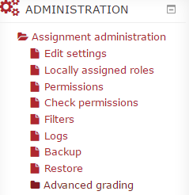
3. The Administration block is ‘intuitive’. It changes depending upon what page in Moodle you have open. Everything under Administration pertains to the assignment you have selected. Click Advanced grading under the Administration block.

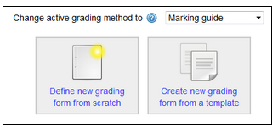
- The Advanced grading page will appear. Set Marking guide for "Change active grading method to".

- Click Define new grading form from scratch.
The Marking Guide settings page will appear.
- Type a Name. Use a name that is easily identifiable so that you may reuse or edit the Marking Guide for other assignments.

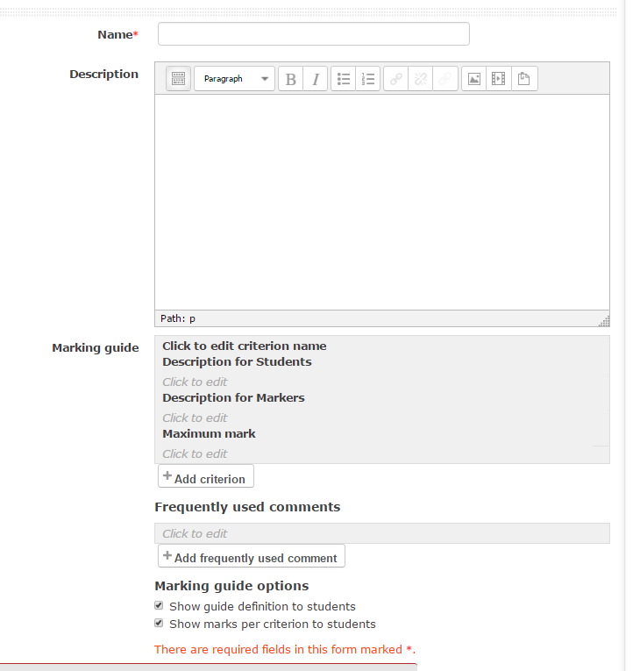
6
Optional: Do you need to describe this Marking guide for other users? If not, ignore.
7
Description for Markers: Do you have multiple people using the Marking Guide? Do you need to provide guidelines on how to mark? Only instructors will see these guidelines.

- Click on Click to edit criterion name in the Marking guide section and type a criterion name, description, and maximum mark. The Description for Markers is used when you have multiple markers. It is optional.

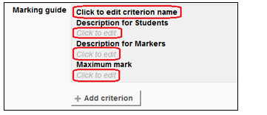

- You can add new criterion by clicking on the Add criterion button.
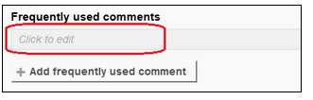
- Using the frequently used comments is an optional feature. If you regularly use the same comments when you are marking, this will speed up your marking.

- You can add another "frequently used comment" by clicking on the Add frequently used comments button.
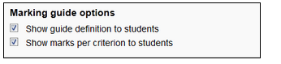
- Choose the Marking guide options.

- Click on the Save marking guide and make it ready button.
Marking Assignments
- Click on the Assignment activity.
- Click View/grade all submissions.
- Click on the Grade icon in the Grade column.
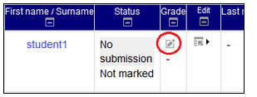
The marking form will appear with criteria.
- Click on the comment box and type a comment or click a comment from the frequently used comments list.
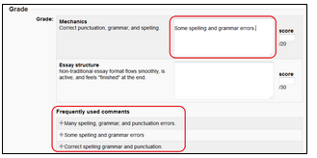
- Click on the score box and type grades.
- Type Feedback comments and attach a file, if it is necessary.
- Click on the Save changes button or the Save and show next button.
Use a Previously Created Marking Guide for another Assignment in a Moodle Course
- Click on another assignment.
- Click on Advanced grading under the Administration block.
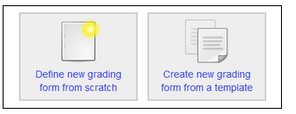
- Click on the Create new grading form from the template button.

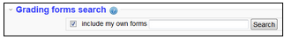
- Check the Include my own forms checkbox and click on the Search button.

- The marking guides that you create will appear.
- Choose the Marking guide by clicking the Use this form as a template button next to the Marking guide.
To Edit or Delete a Marking Guide
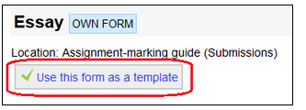
- Go to the course home page.

- Click on the Assignment activity.
- Click Advanced grading under the Administration block.
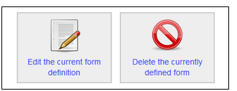
- To edit the Marking guide: click on the Edit the current form definition button.
To delete the Marking guide: click on the Delete the currently defined form.

For more Information please see Marking Guides at Moodle.org or contact Moodle Help.

